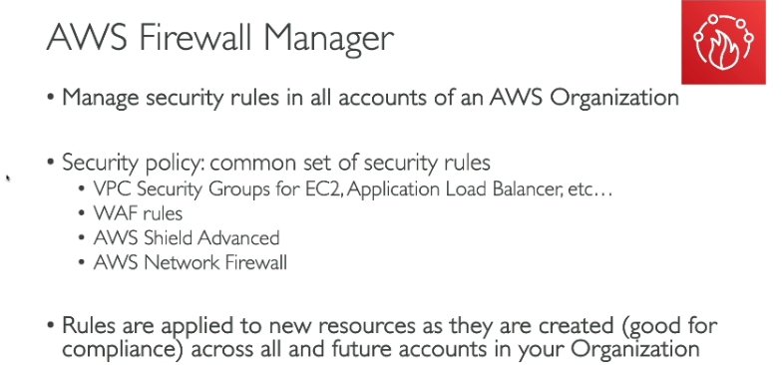

A central place to manage the security rules for all the accounts